光診 hw_7

R08945015 許逸翔

**Multiple-layer tissue model**

Develop a multiple layer model and compute R, T and fluence rate distribution for the tissue shown in the diagram below. Let Δr = Δz = 0.025 mm. Use variable weight photons and Henyey-Greenstein phase function. Assume the incident light is a collimated beam at normal incidence.

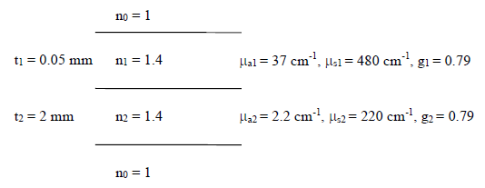

1. Plot the absorption distribution of scattered photons (1/cm3 ) and the impulse response (infinitely narrow incident beam) for the fluence rate of the scattered photons (1/cm2 ), both in 2D (r and z).
2. absorption distribution of scattered photons (1/cm3 )
3. absorption distribution with r

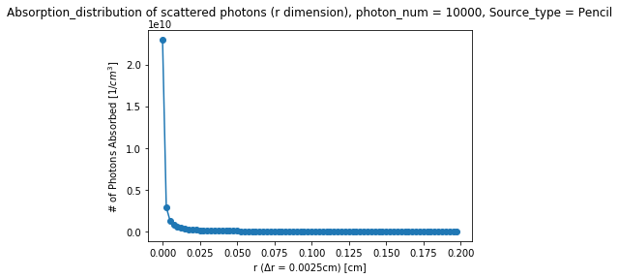

1. absorption distribution with z

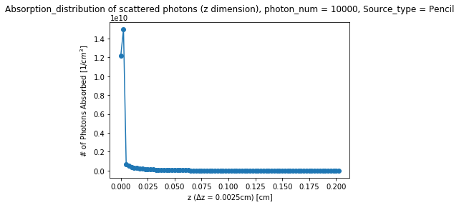

1. fluence rate of scattered photons (1/cm2 )
2. fluence rate with r

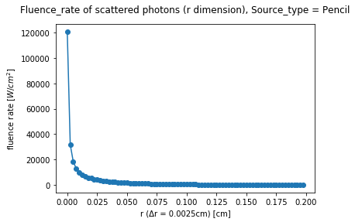

1. fluence rate with z

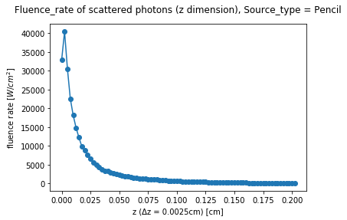

1. Assume the incident beam having a Gaussian intensity profile with an 𝑒−2 radius of 0.5 mm and total power of 1W. Plot the fluence rate (W/cm2 ) in 2D (r and z). Report the total reflectance R (should be approximately 0.21) and the total transmittance T (should be about 0.01).
2. Result for total reflectance R & total transmittance T

|  |  |  |  |  |  |  |  |
| --- | --- | --- | --- | --- | --- | --- | --- |
| No. | 1 | 2 | 3 | 4 | 5 | Mean | Stdev |
| R | 0.2206 | 0.2275 | 0.2158 | 0.2209 | 0.2197 | 0.2209 | 0.0042 |
| T | 0.0117 | 0.0119 | 0.0117 | 0.0123 | 0.0115 | 0.0118 | 0.0003 |

1. Plot the fluence rate (W/cm2 ) in 2D (r and z) – total power of 1W
2. fluence rate with r

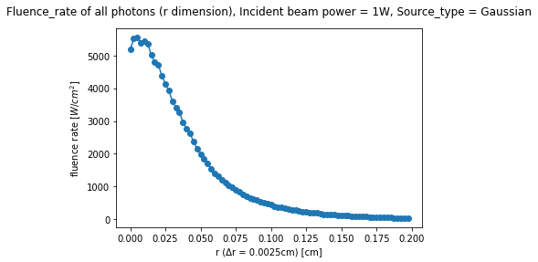

1. fluence rate with z

